Project Submission
Jeremy Schwartzbord
April 17th, 2026
Project and Data Configuration and Preparation
Criteria | Submission Requirements
AI model is deployed within the project | Screenshots or logs show the successful deployment of a base model  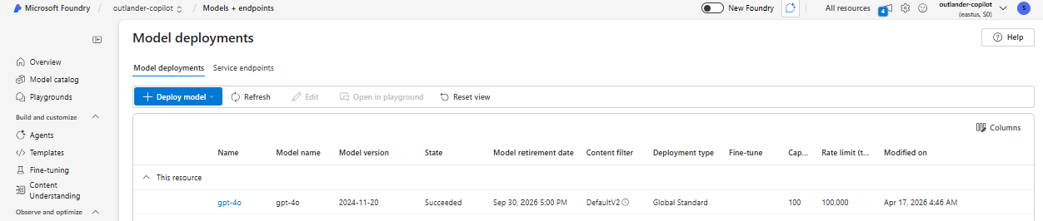  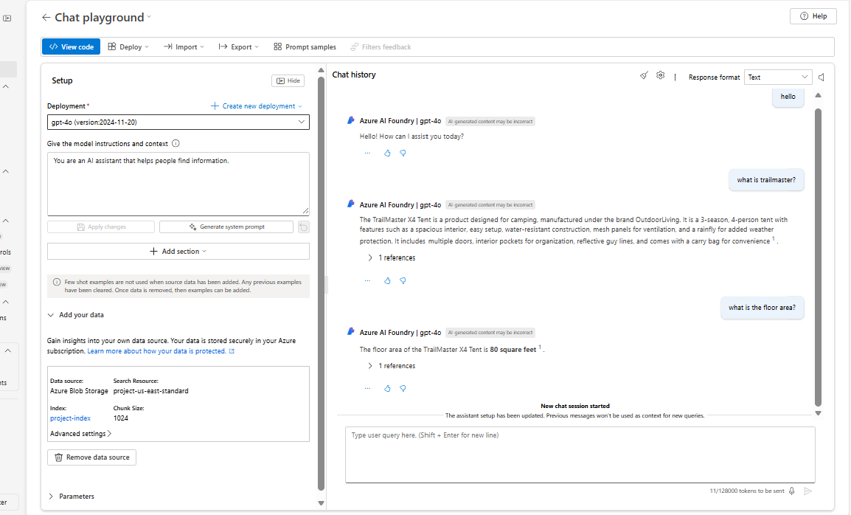
Upload and management of data in AI Studio | The copilot responds using data grounded from a data source, and evaluations are created against the data source.  Data:  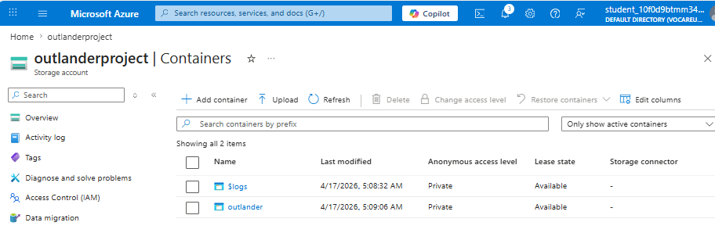  Management of data in AI Foundry  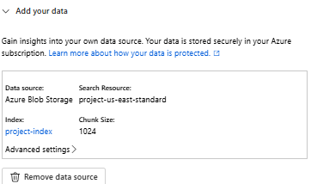  Evaluation Data  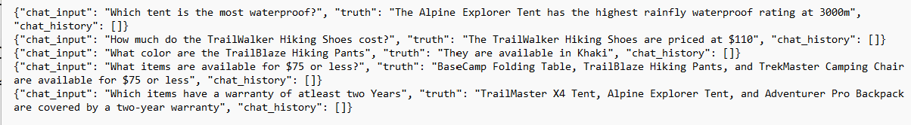  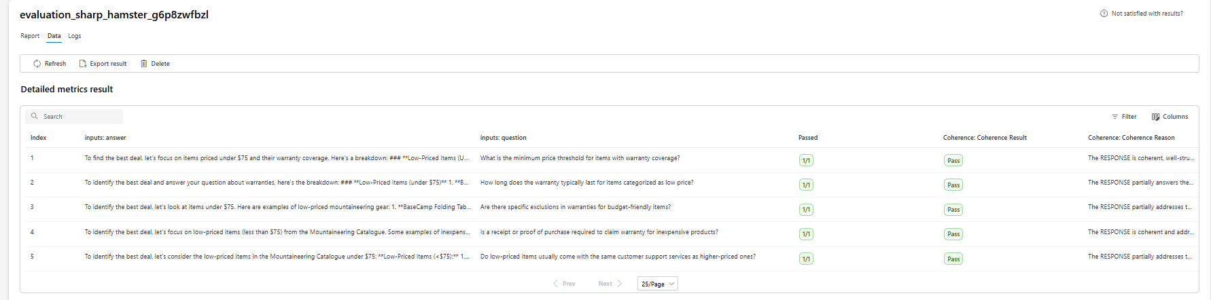
AI Search index using the uploaded data | The copilot application uses an AI Search Service evidenced by functionality or screenshots  AI Search Service:  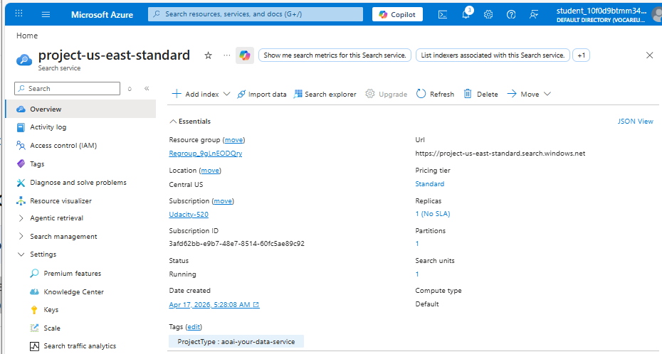  AI Search Service integration.  to outlander container  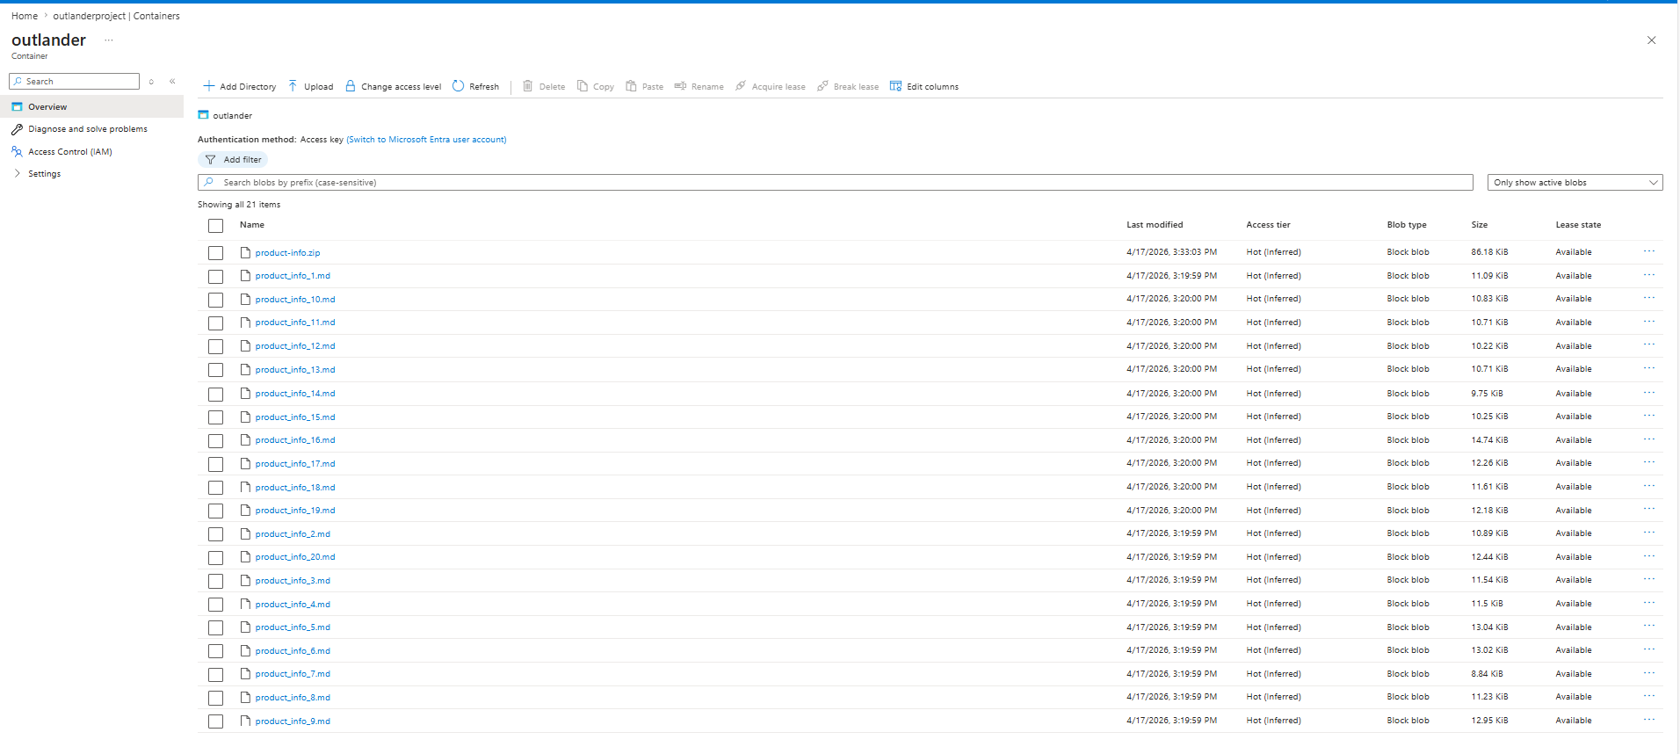  OutlanderProject storage account  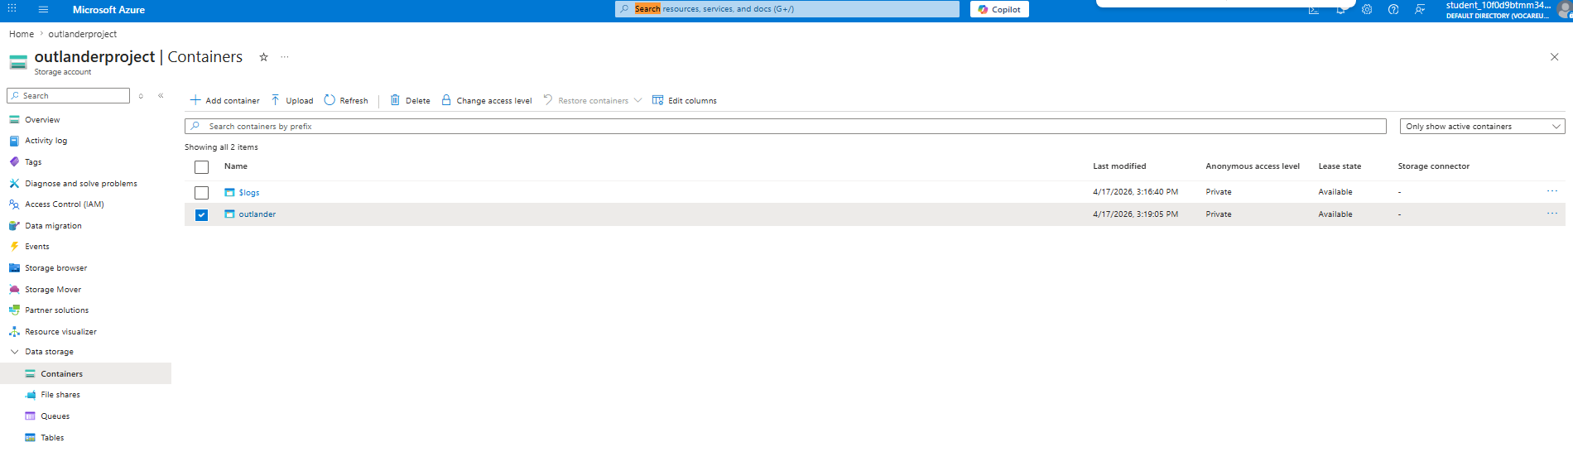  Index includes data uploaded to outlander container in the outlanderproject Azure Blob Storage Account  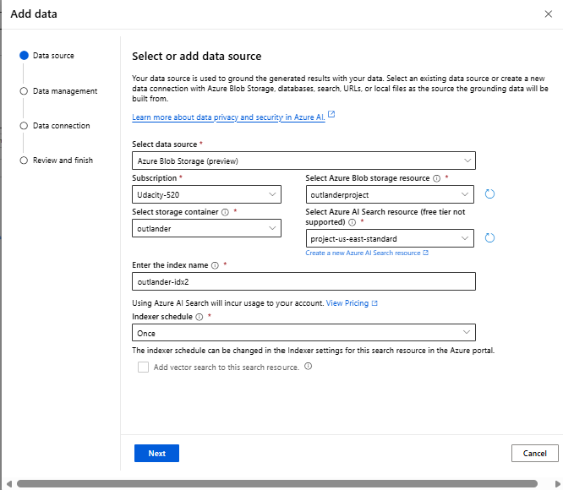  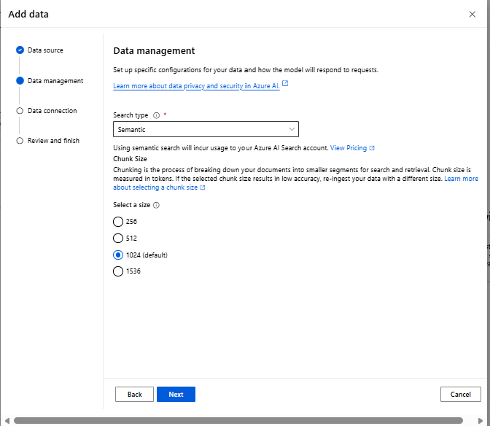  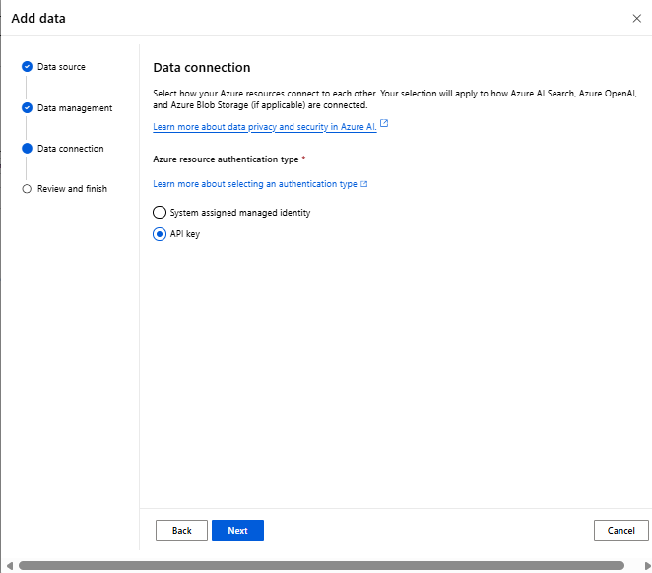  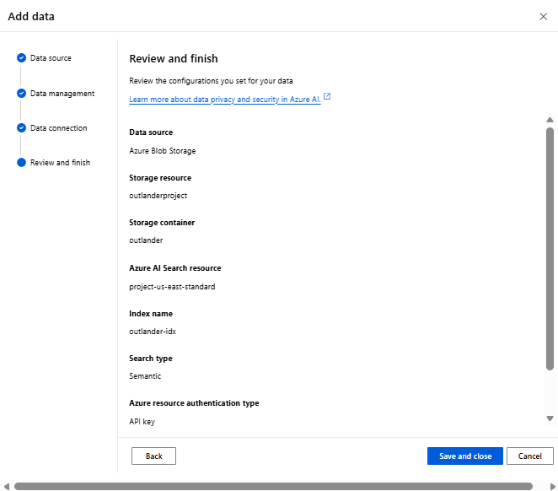  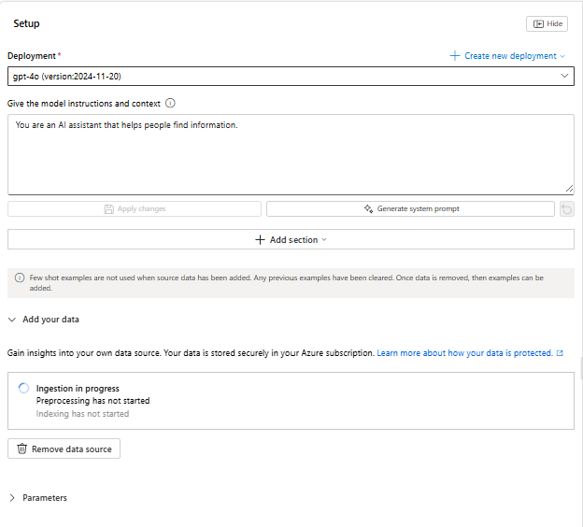  Indexed data (below, left) are integrated and enabled as shown in chat platground (below, right)  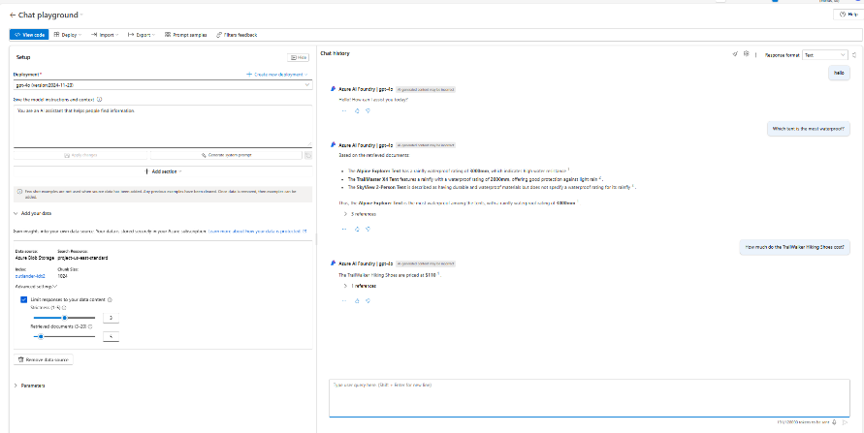  Functionality of Search Service in Copilot  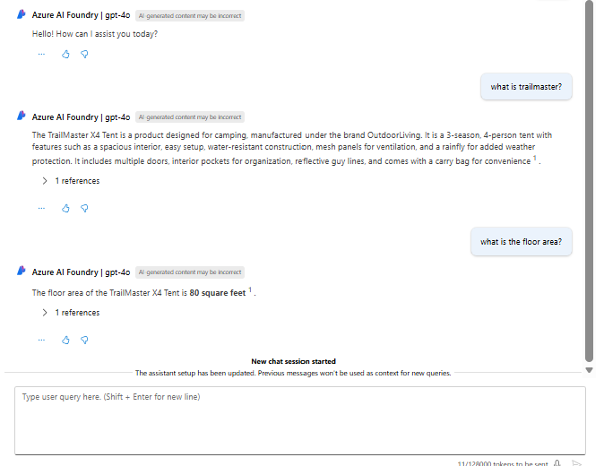
Copilot App Development
Criteria | Submission Requirements
Implementation of Prompt Flow for the custom AI Copilot | 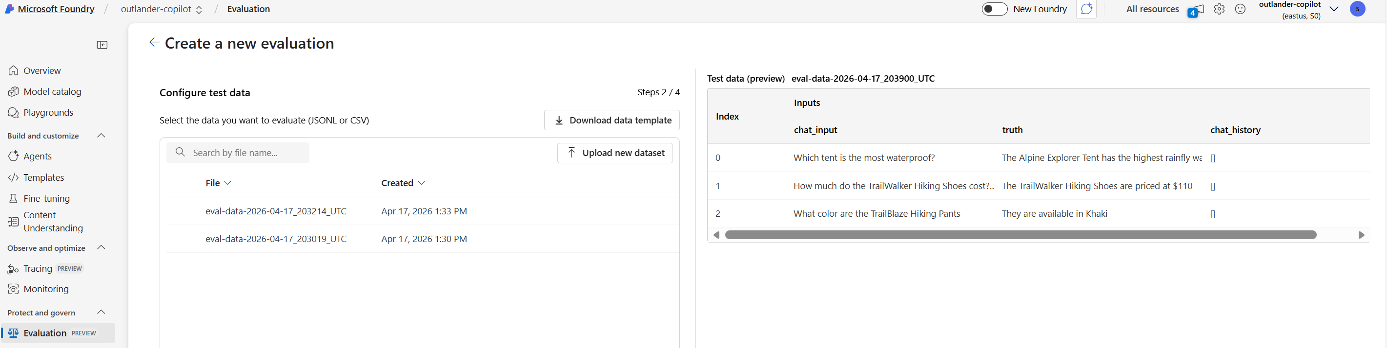  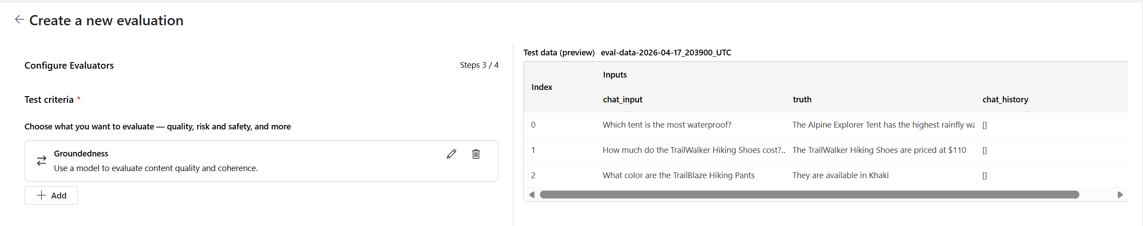
The Copilot is tested with relevant questions. | Screenshots show accurate responses to evaluation questions.  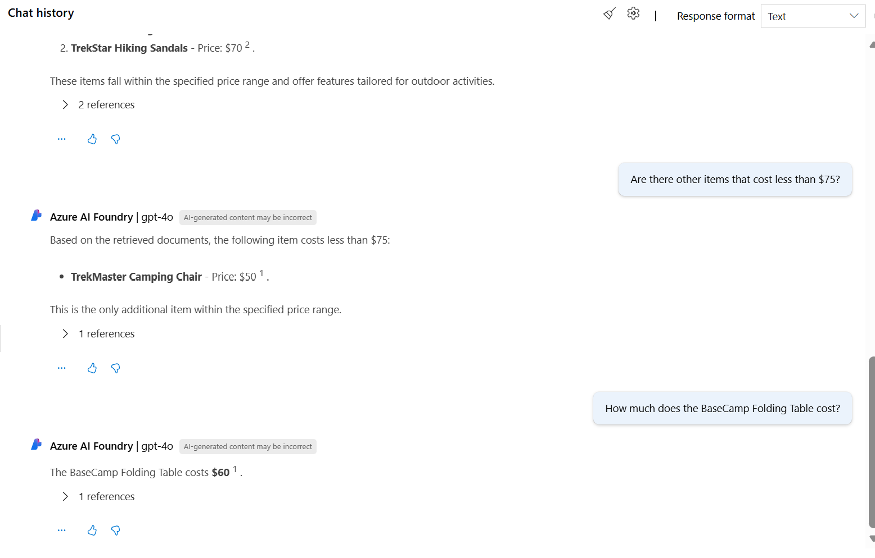
Evaluation of the Copilot
Criteria | Submission Requirements
The automated evaluation of the copilot is performed with a structured dataset | JSONL or CSV evaluation dataset provided and used in AI Studio for evaluation. Metrics and results from the automated evaluation are included in the submission.  JSONL dataset Automated Evaluation    Metrics and Results  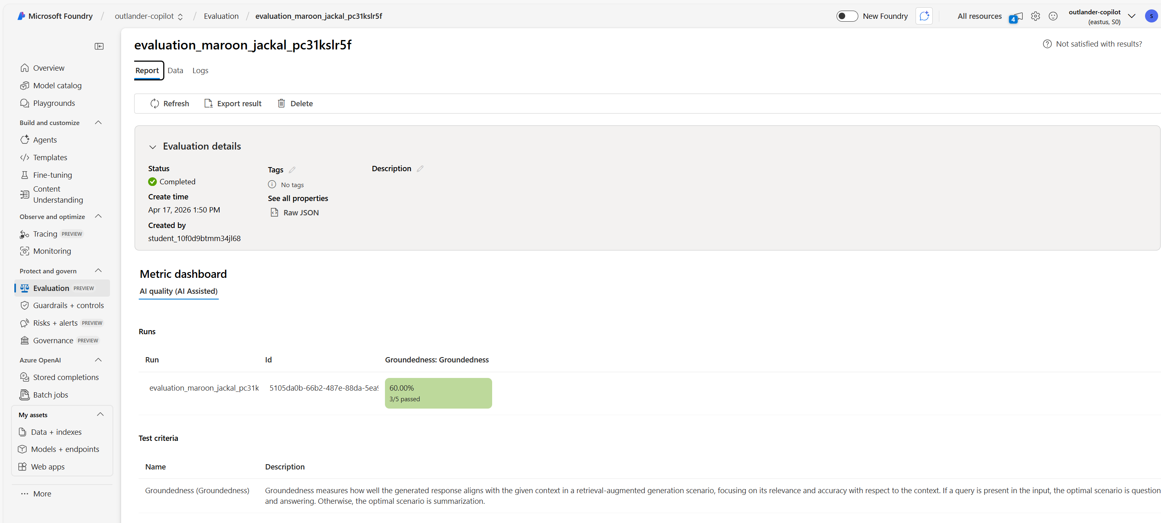  AI Assisted Evaluation  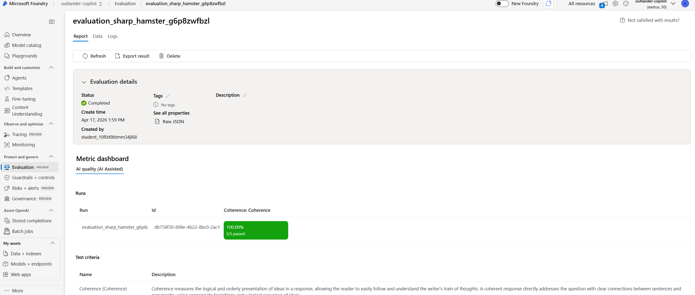  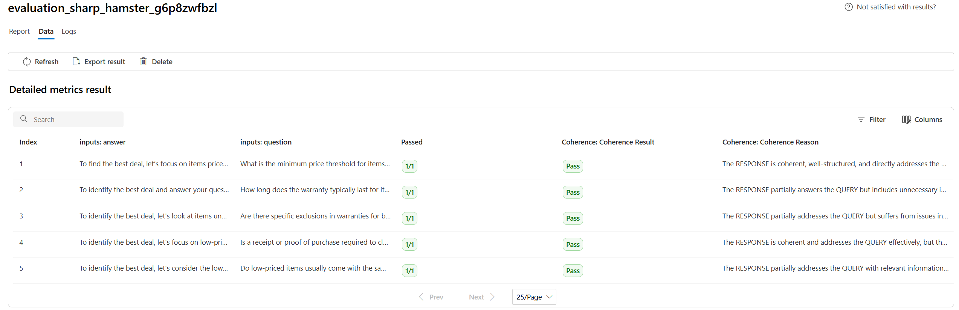
Manual prompt evaluation is conducted | Evidence/screenshots of manually added questions and responses with feedback provided  
Deployment
Criteria | Submission Requirements
The copilot is deployed successfully and verified | Screenshots of the deployment confirmation with endpoint information included.  Deployment with Endpoint  